|  |  |  |  |  |  |  |  |  |  |  |
| --- | --- | --- | --- | --- | --- | --- | --- | --- | --- | --- |
| **CS102 - Spring 2024/2025**   |  |  |  |  | | --- | --- | --- | --- | | **Instructor:** | Uğur Güdükbay | **Section No:** | **3** | | **Assistant:** | Ebrar Bozkurt | |  |  |  |  | |

**~BILKOM~**

**Group0 / 3h**

**Group Members**

|  |  |
| --- | --- |
| **Name** | **Surname** |
| Ali İhsan | Sevindi |
| Elif | Bozkurt |
| Salih Mert | Uzun |
| Sıla | Bozkurt |
| Utku | Kabukçu |

|  |
| --- |
| **User Interface Report V1 Due: 30 March 2025** |

**,**

**1. Introduction**

  
Bilkom is an application aimed to provide a platform that will help students connect and socialize in the Bilkent Campus. Even though opportunities present themselves, sometimes traditional ways of socializing often fall short, mainly due to complex school life and vast campus, making it challenging for students to come by similar-minded peers. Considering these factors, the need for a platform where we can enable the gathering of people for activities and develop a platform designed to help students connect and socialize more effectively is clear. Our mission is to create an app dedicated to enhancing student’s social life and creating a safe space for people with similar interests to come together. While doing this, we will create a user-friendly interface that would be easy for students to use.

Previously, we introduced what we will do on this platform and what and how we plan to achieve our goal. In this report, we aim to show how Bilkom stands out regarding sustainability and usability compared to similar applications. To achieve this, we’ve designed a clean and intuitive interface where each window is structured clearly, and every button’s function is explained with practical examples. The user interface was developed with careful attention to simplicity and appeal, ensuring that students can easily navigate the platform. As a community-driven app, visual clarity and engagement were prioritized—featuring original logos, color-coded labels, and accessible button layouts to enhance the overall experience.

**2. Details**

**2.1 Storyboard**

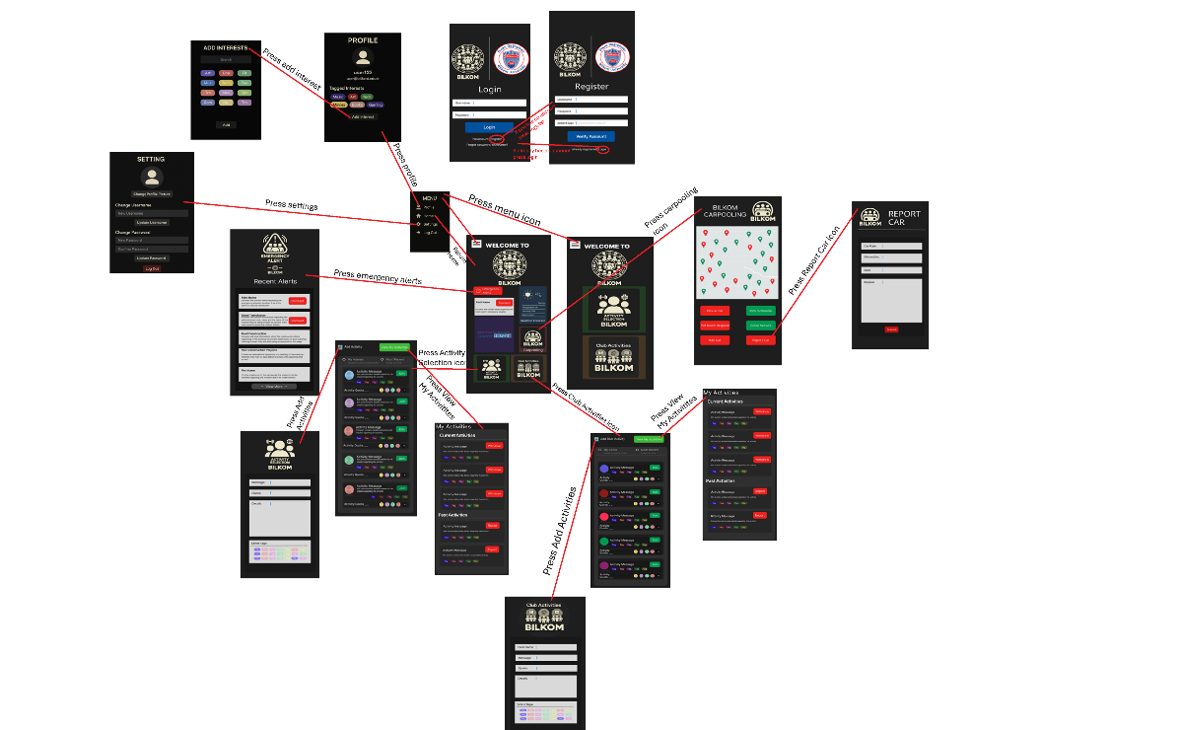

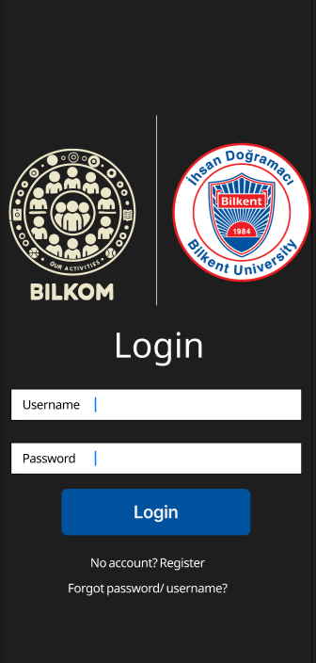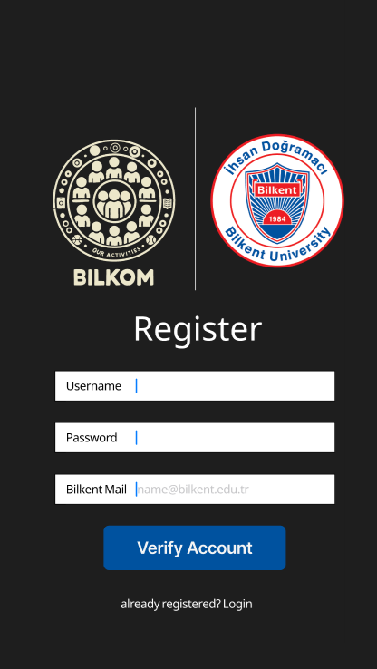**2.2 Registration and Login**

After downloading app we are welcomed with a login page (Left):

You can login only using your username and password no additional correction step is required. If you don’t have an account there’s a link that directly sends user to the registration page. Bottom of the page there’s a panel stating “No account? Register.” When you click on underlined register, registration page is opened.

You can also click on forgot password and change your current password by validating your Bilkent Mail. The link in the mail will lead to the same page as the change password page on settings.

In registration page(Right), you enter username and password but also your bilkent mail to make sure that only students of Bilkent can access to this platform. This makes it possible that when logging in to two-factor authorization is unneeded. Similarly if you have an account and wish to skip registration you can click on login on the label “Already registered? Login.” and you’ll automatically be directed to that page.

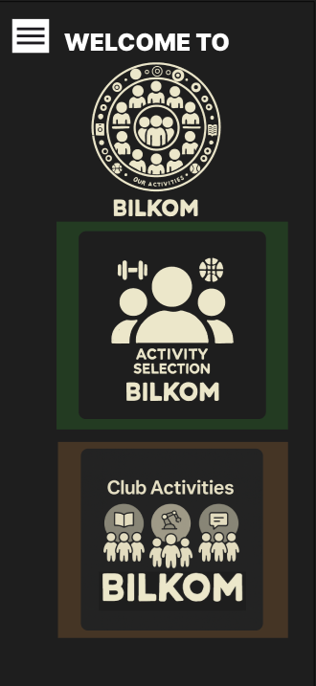**2.3 Home Page and Menu**

This is the layout of our homepage (left one is with all the possible implementations added and the right one is the original planned version without any implementation). When the users login or if they had logged in the app beforehand this is the page that automically comes in front of them. In home page we are greeted with Bilkom’s logo and a welcome label. Home page composes of components: shortcuts to activity selection pages (for both club and non-club) and widgets for our possible extensions: a frame that displays news, another frame that displays weather forecast, emergency alerts button and most recent emergency alert with a preview, and 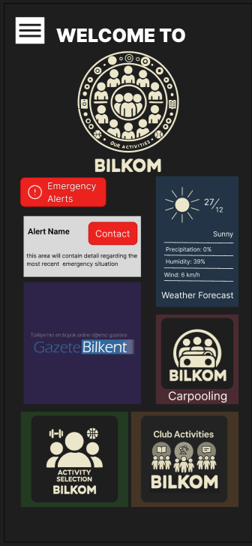another shortcut to carpooling service.

Shortcut buttons for activity selection are marked with their specific logos:

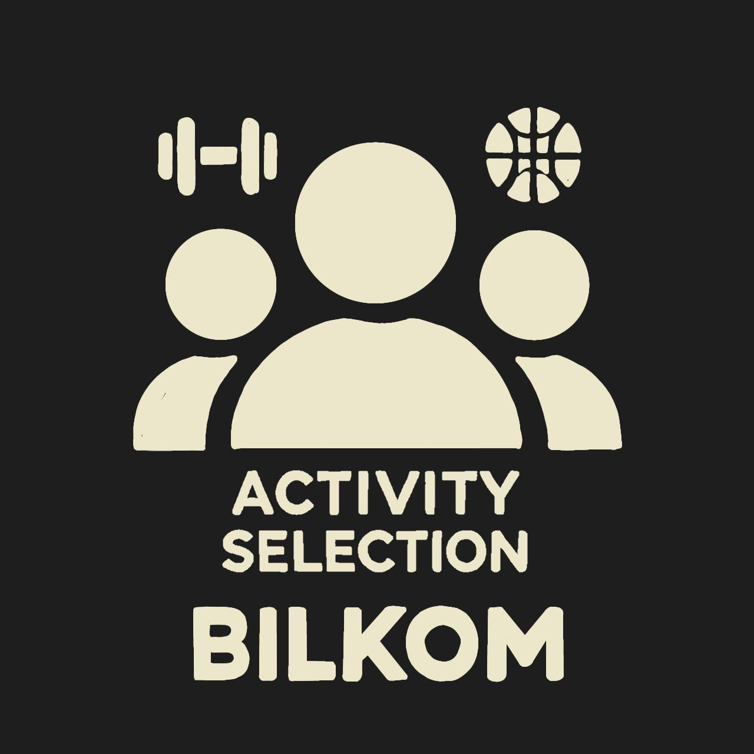

Clicking on these buttons will directly lead user to the pages designed for activity selection.

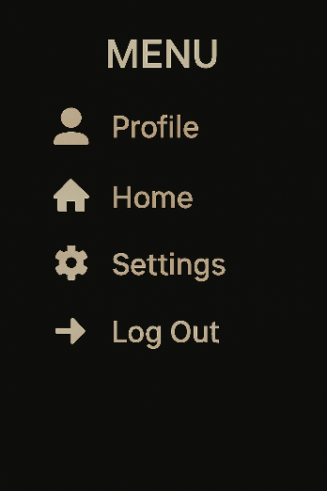

To improve overall accessibility and streamline navigation, a fixed Menu Bar is placed at the top-left corner of every page in the application. This menu provides users with quick shortcuts to the most essential sections of the app and reinforces a seamless and efficient navigation experience across the Bilkom platform.. The menu includes the following items:

1. Profile:  
   Serves as the user’s personal space where they can view and edit their details, including username, email, profile picture, and other personal preferences. Positioned at the top for immediate recognition and access.
2. Home:  
   Instantly redirects the user to the homepage, where emergency alerts, activity shortcuts, weather updates, and campus news are conveniently displayed.
3. Settings:  
   Opens the settings page, allowing users to fine-tune their experience by changing their password, customizing notification preferences, or managing account security.
4. Log Out:  
   Securely logs the user out of their account. Positioned at the bottom of the menu to indicate its role as the final, deliberate action in a session.

**2.4 Activity Selections**

While creating and choosing an activity you can choose from two following options:

1. Non-Club Activities
2. Club Activities

Links to these pages can be reached from the home page.

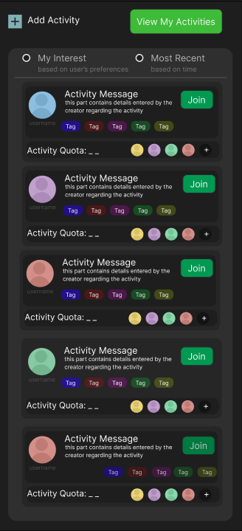***2.4.1 Non-Club Acitivty Page***

**2.4.1.1 Main Page for Non-Club Activities.**

This page is opened after clicking the add activity button on the home page. On the top pf the page there are 2 buttons: Add Activity Button and View My Activities Button.

Below that there are radio buttons that allwo users to filter activities based on 2 criterias: user’s preferences and adding time of the event. To filter for user’s preferences, the preference tags determined by the user from their profiles. The activities tagged by that tags are listed when that choice is selected. For recency list by the adding time of the event is looked at.

Users can immediately view 5 details for the event:

1. Organizer’s Username and Profile Picture
2. Activity Message and Details
3. Interest Tags
4. Quota of the Event: both actively participating and remaining (active / remaining)
5. Profile Pictures for the Attendees: is it’s more than 5 there’s a “+” button implies there’s more than that.

The event is automatically removed from the main page if the quota is full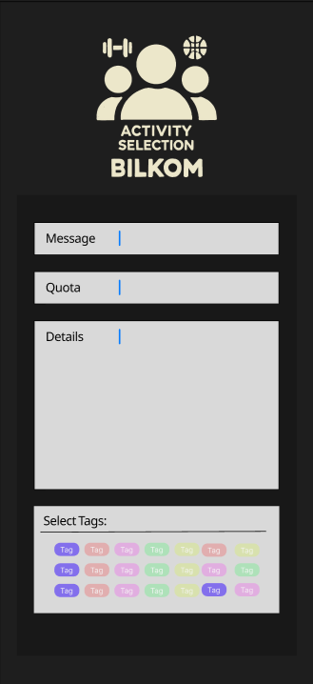.

**2.4.1.2 Adding a Non-Club Activity.**

To add a non-club activity user needs to implement 4 things:

1. Message : Write what user wants to state immediately at first interaction. For example: “Two more people is needed for an Okey Game, Urgent!”
2. Quota: User enters how many people might attend to the event.
3. Details: details regarding where and when the event will take place also additional details for criteria is added by the user. (optional)
4. Interest Tags: to be able to let other users filter this activity by their interests tags matching the events description is checked from the list.

The places for implementation are listed below a specific logo for activity selection. Tags are colored with different color to improve visuality as well as for readability.

**2.4.1.3 Viewing User’s Non-Club Activities.**

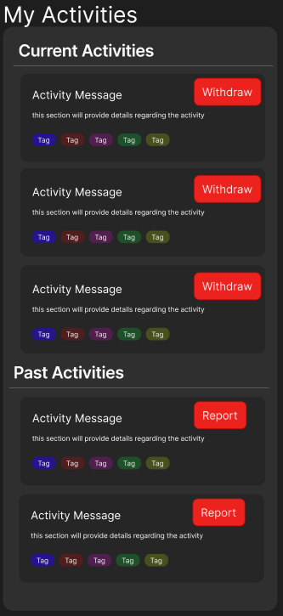 This page is accessed from clicking on the “View My Activities” button from the Activity Page. In this page user can view their current activities and past activities. Each label contains exact information provided on activity selection’s main page.

***2.4.1.3.1 Reporting Past Activities.***

Users can withdraw from events using withdraw button. This button removes users from events quota, therefore attendee list for the event. If the user is also the organizer of this event withdrawing would delete the event from application’s activities automatically removing all the attendees and this event from their activity list. After clicking on withdraw a pop-up frame would appear stating “You Withdrawed from the Event + event’s message”.

***2.4.1.3.2 Withdrawing From An Activity.***

Users can also report their past activities on a pop-up frame only stating the reasons to report whether it me misconduct/ abuse/ mislabeling. As Bilkom we want to prevent such problems for the students of bilkent therefore we wish to provide a simple interface for users to report their problems to. Reports would be directly send to the corridnators and afterwards if necessary for disciplinary action be sent to Bilkent competents.

***2.4.2 Club Activity Page***

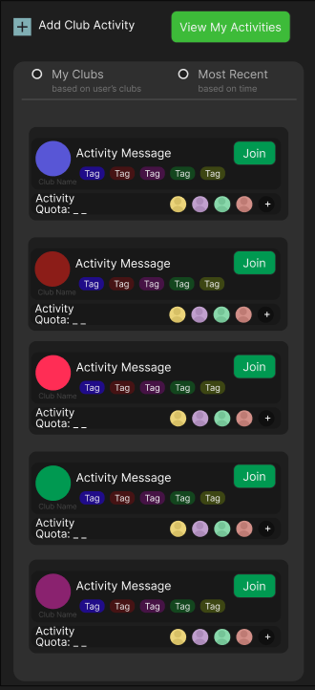**2.4.2.1 Main Page for Club Activities.**

This page is opened after clicking the add club activity button on the home page. Overall, this page is almost identical to club activity page except add activity button is only activated for users with a club badge which they receive after contacting us and we activate this button if they are the member of the club that is responsible for organizing the events.

On each activity label there are 5 details user can immediately access:

1. Club Badge and Name: automatically assigned after the orgznizer adds the event for their club, writing their name.
2. Activity Message
3. Interest Tags
4. Activity Quota
5. Profile Pictures of the Attendees

**2.4.2.2 Adding a Club Activity.**

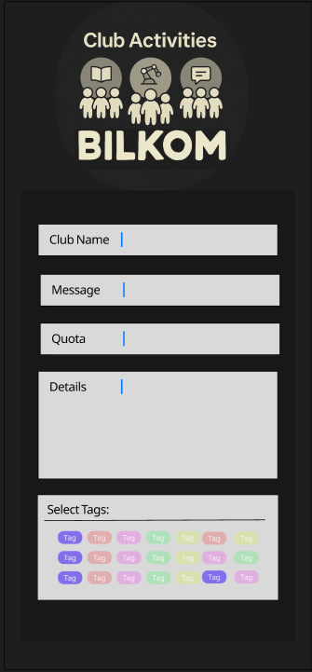To add a non-club activity user needs to implement 4 things:

1. Club Name: Among the listed clubs the user will choose one of them
2. Message : Write what user wants to state immediately at first interaction. For example: “ACM Movie Night!”
3. Quota: User enters how many people might attend to the event.
4. Details: details regarding where and when the event will take place also additional details for criteria is added by the user. (optional)
5. Interest Tags: to be able to let other users filter this activity by their interests tags matching the events description is checked from the list.

**2.4.2.3 Viewing User’s Club Activities.**

Same page as viewing non-club activities of the user. The methodology for withdrawing from and reporting the event is also the same.

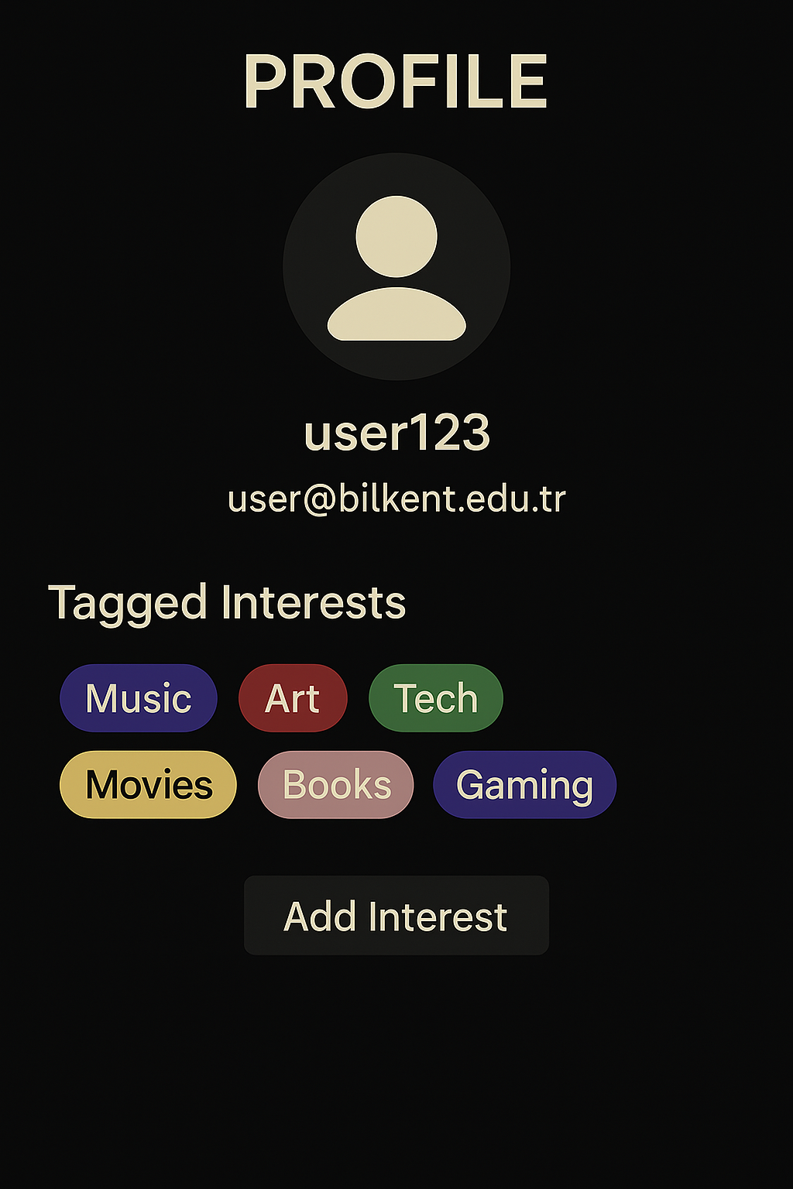**2.5 User Profile**

Upon entering the profile page, users are presented with:

1. Profile Picture  
    A circular placeholder or existing image representing the user. This adds personalization and familiarity.
2. Username  
    The currently set username is displayed in large text beneath the profile picture.
3. Bilkent Mail  
    The user's verified Bilkent email address is shown under the username, highlighting their authenticated status within the student-only platform.
4. Tagged Interests  
    A key component of the user experience. The page displays the interests previously selected by the user in a horizontal tag layout. Each interest tag is uniquely color-coded for improved visibility and aesthetics. These interests are later used to filter and recommend activities across the platform.
5. Add More Interests Button  
    A prominent button labeled “Add Interest” directs users to a dedicated screen where they can explore and select additional interests from the platform’s pool. This encourages continuous engagement and ensures the algorithm remains up-to-date with the user’s evolving preferences.

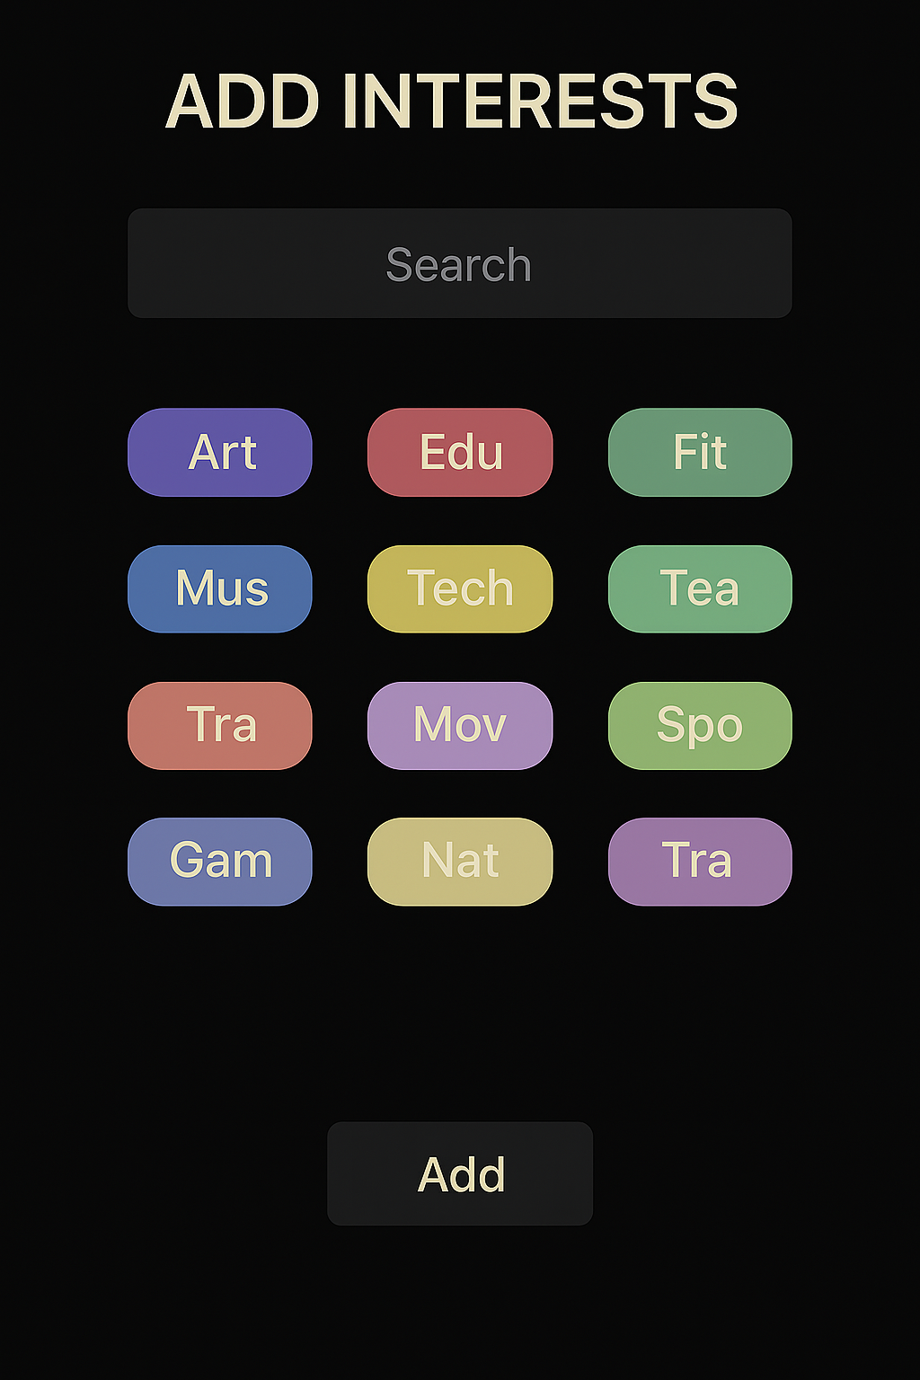***2.5.1 Tagging Interests***

Upon entering the page, users are presented with:

1. Search Bar  
    Located at the top of the page, this input allows users to type keywords and quickly filter interest tags from the pool. It provides real-time suggestions, simplifying the search for specific interest areas.
2. Tag Pool Grid  
    Below the search bar, a scrollable grid layout displays a variety of interest tags. Each tag is enclosed in a rounded box with distinct colors, making them easily distinguishable and visually appealing. Tags represent activities such as "Board Games," "Basketball," "Volunteering," "Karaoke," and more. The wide variety ensures inclusivity for different student preferences.
3. Add Button  
    Once a tag is selected, an “Add” button becomes active at the bottom of the page. Upon pressing it, the selected interests are added to the user’s profile and used for event filtering and recommendations throughout the app.

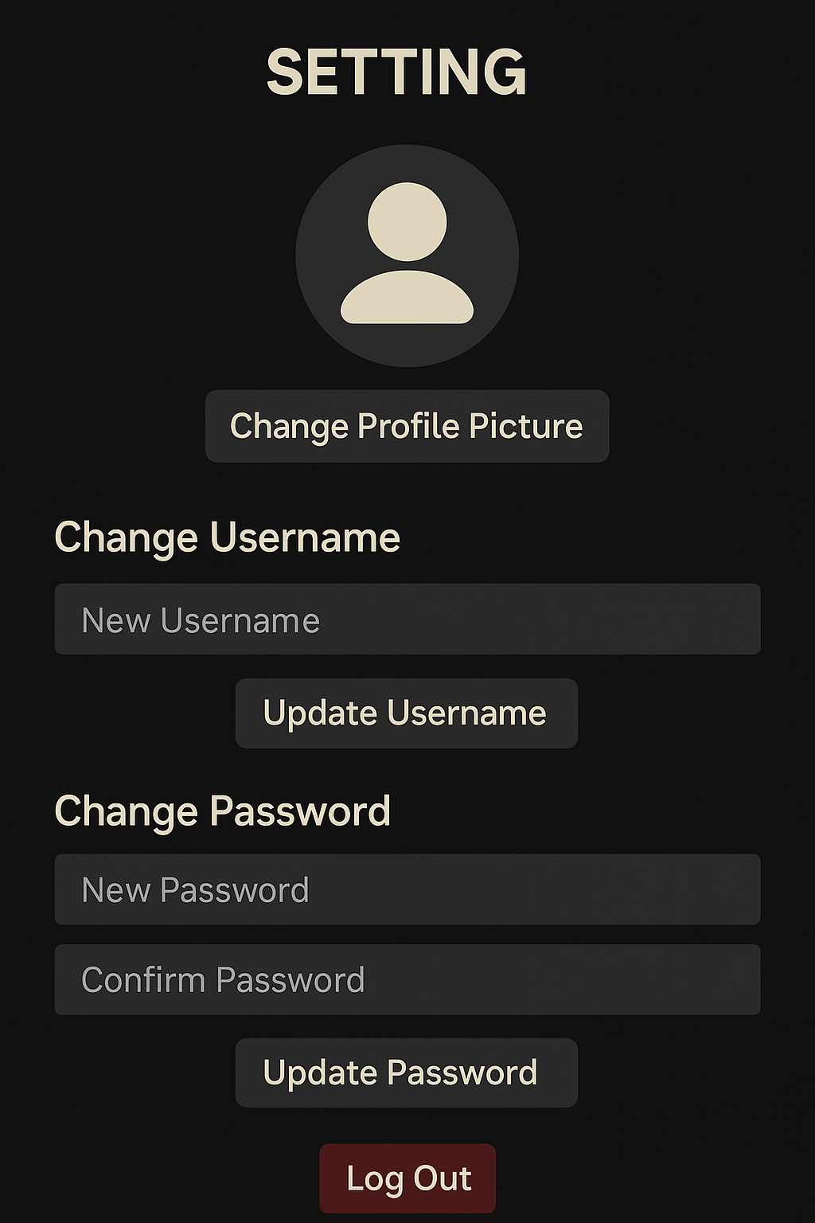**2.6 Settings**

This page is accessed from the menu tab. The page includes the following features:

1. Change Profile Picture:  
    At the top of the page, the user is shown a circular placeholder representing their profile picture. A button labeled "Change Profile Picture" allows users to update their photo, creating a more personalized experience.
2. Change Username:  
    Below the profile section, users can input a new username in a clearly labeled field. Upon pressing the "Update Username" button, the new username is applied.
3. Change Password:  
    Two fields are presented for password updating: one for the new password and another for confirming it. After entering valid inputs, users click the "Update Password" button to finalize changes. This aligns with the app’s security policy while maintaining usability.
4. Log Out Button:  
    Positioned at the bottom of the page, a red "Log Out" button provides a clear and immediate way to exit the application. Its color and positioning reinforce its importance as a final action.

**3. Possible Extensions**

 **3.1 UI For Possible Extensions in General**

We are planning to forecast articles and news from gazetebilkent.com and bilkentnews.com on the home page. Alongside with a live-streamed weather forecast for Bilkent Campus.

We plan to have an emergency alerts button that transfers users to Emergency Alerts page on click just under the logo. Below it there’s also a preview of the most recent emergency alert. If it’s alert that provides a contact you can click on the contact and go directly to its page.

**3.2 Emergency Alerts**

This page is opened after clicking the emergency alerts button on the ho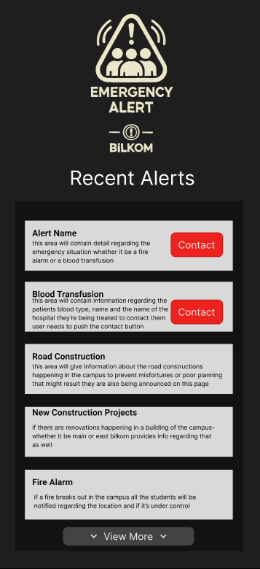me page. Below the specific logo the lates emergencies in the last 48 hours are listed. When looking at an emergency alert the user will be immediately notitfied about 3 main information:

1. Alerts Name
2. Alerts Detail: location, people involved, if it’s a blood/organ transfusion location for a hospital, where and when it will take place and if’s not an event but a process how long it will take place
3. Type of the Alert: “Contact” button will only appear when if it’s an event that requires contact to another individual like a an emergent blood transfusion

Clicking on View More will open more emergencies and user will be able to scroll down to see them.

***3.2.1 Contacting to Emergency Alerts***

After clicking on the contact button the details will be delievered to the users Bilkent Mail immediately. No new frame will be opened.

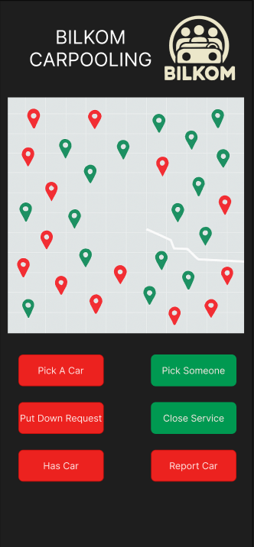**3.3 Carpooling**

This page is accessed from the the Carpooling button available from the main page. On this page there are 2 main components:

1. Map
2. Buttons: red buttons are for carpoolers and green buttons are for ones ready to pick someone up

***3.3.1 Map***

The central feature of the Carpooling page is a live map showing user locations within and around the Bilkent campus. The map serves as a visual representation of carpool availability in real time:

1. Green markers indicate users who are currently offering a ride. These markers become visible after submitting the "Offer Ride" form.
2. Red markers represent users who are requesting a ride. These appear after a user submits the "Request Ride" form.

Markers are clearly labeled to prevent confusion, and clustering is handled dynamically to maintain readability.

The map supports zooming and panning, allowing users to explore the surrounding areas and view more distant carpool options. By using color-coded markers and real-time updates, the map helps students identify nearby opportunities efficiently and encourages immediate action.

***3.3.2 Requesting A Car***

To request a car the user needs to press the “Pick Car” button and write a short message to the pop-up frame. Pick A Car button immediately publishes user’s location ont he map, visible to other users. If the user does not want to continue requesting the service they can press the put down request button. If the User gets onto a car they will press Has Car button. This method is important because if a problem occurs and they want to report the car/ driver for a certain problem they can easily do so.

***3.3.3 Opening Service For Carpooling***

Opening Carpooling Service has 2 buttons:

1. Pick Someone: This feature enables drivers to formally announce their intent to pick up passengers. When the Pick Someone button is pressed, the system automatically places the user’s location on the live map as a green marker, signaling that they are currently available to offer a ride.

After pressing the button, a pop-up form appears prompting the driver to enter a starting point and a destination. These fields help other students evaluate the ride’s route and decide if it fits their own commuting needs. Once submitted, the driver becomes publicly visible to potential riders on the map, and their route preferences become linked to their profile marker.

1. Close Service: When a driver is no longer available to offer a ride—either because their car is full, their ride is completed, or they no longer wish to participate—they can press the Close Service button.

This immediately removes their green marker from the map, signaling to all other users that the carpooling service has been discontinued for that session. This function is vital to avoid confusion or outdated information being displayed on the carpooling map. It ensures only currently active and available drivers are visible, preserving the clarity and efficiency of the system.

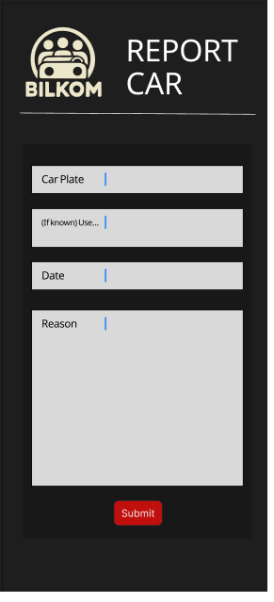***3.3.4 Reporting A Car:***

This page is reaced through the main page of carpooling. The Report Car Page provides users with a simple and direct way to report concerns related to the carpooling service. This feature is essential for maintaining safety, accountability, and overall trust in the platform.

The layout follows Bilkom's signature dark theme with cream-colored labels and light gray input fields. It includes the following input sections:

1. Car Plate  
    A mandatory field where users enter the license plate number of the vehicle they are reporting. This helps identify the car in question for further follow-up.
2. Username (Optional)  
    An optional field for entering the username of the driver, if known. This helps strengthen the report with additional context but is not required.
3. Date  
    A required field that allows the user to specify when the incident occurred. This ensures that reports are time-specific and verifiable.
4. Reason  
    A larger text area where users provide a detailed explanation for the report. The app encourages concise but informative descriptions, such as issues of unsafe driving, inappropriate behavior, or violation of community standards.
5. Submit Button  
    A red, clearly visible button labeled "Submit" is positioned at the bottom of the form. Once clicked, the report is sent to Bilkom’s moderation system for review. Follow-up actions may be taken if deemed necessary by the administration or, if needed, university authorities.

**4. Possible Problems**

While Bilkom’s interface is clean and intuitive, several underlying challenges may emerge as the platform scales. First, the interest tagging system, though useful for personalization, risks becoming oversaturated as more users and tags are added. Without categorization or bundling, users may experience filter fatigue, reducing the effectiveness of discovery and limiting engagement across diverse activity types. Second, the carpooling map, which depends on real-time location markers, may suffer from visual clutter—particularly around high-traffic zones—leading to overlapping icons and untappable areas. The absence of clustering or adaptive zoom mechanisms could render the map ineffective under heavy usage. Lastly, role-based restrictions, such as club-only activity creation or driver-specific controls, are not clearly communicated within the interface. Users who encounter disabled buttons without contextual explanation may misinterpret limitations as bugs or design flaws, which could frustrate engagement and discourage deeper feature exploration.

**5. Further Improvements**

To further enhance Bilkom’s usability and long-term scalability, several improvements can be considered. Introducing a tag categorization system and smart tag suggestions would streamline interest selection and reduce visual clutter. Implementing dynamic clustering on the carpooling map would address potential overlap issues in high-density areas, while subtle real-time refresh cues could improve user awareness. Adding visible role indicators and a dedicated role status panel would clarify feature access and reduce confusion around permissions. Lightweight onboarding elements such as in-app tutorial pop-ups, confirmation frames for critical actions, and visual quota indicators would support both new and returning users in navigating the platform more confidently and efficiently.

**6. Conclusion**

Bilkom was designed with a clear mission: to create a safe, inclusive, and intuitive platform where Bilkent students can connect, participate in shared interests, and navigate campus life more effectively. Through a carefully crafted user interface, the app balances simplicity with functionality—offering streamlined access to activity planning, emergency alerts, and carpooling services. Each design decision was made with attention to visual clarity, accessibility, and the unique needs of a university environment.

While the current interface meets its core goals, this report has also highlighted areas where scalability, role transparency, and interaction feedback could be improved. By addressing these not-so-obvious limitations and implementing small yet impactful enhancements, Bilkom has the potential to grow into a robust and indispensable part of campus life. The user-first approach at the heart of the platform ensures that, with continued refinement, it will remain responsive to the evolving needs of the Bilkent community.

**References**

[1] Figma Inc., *Figma: Collaborative Interface Design Tool*. [Online]. Available:<https://www.figma.com/> [Accessed: 30-Mar-2025].

[2] Canva Pty Ltd., *Canva: Online Graphic Design Platform*. [Online]. Available:<https://www.canva.com/> [Accessed: 30-Mar-2025].

.